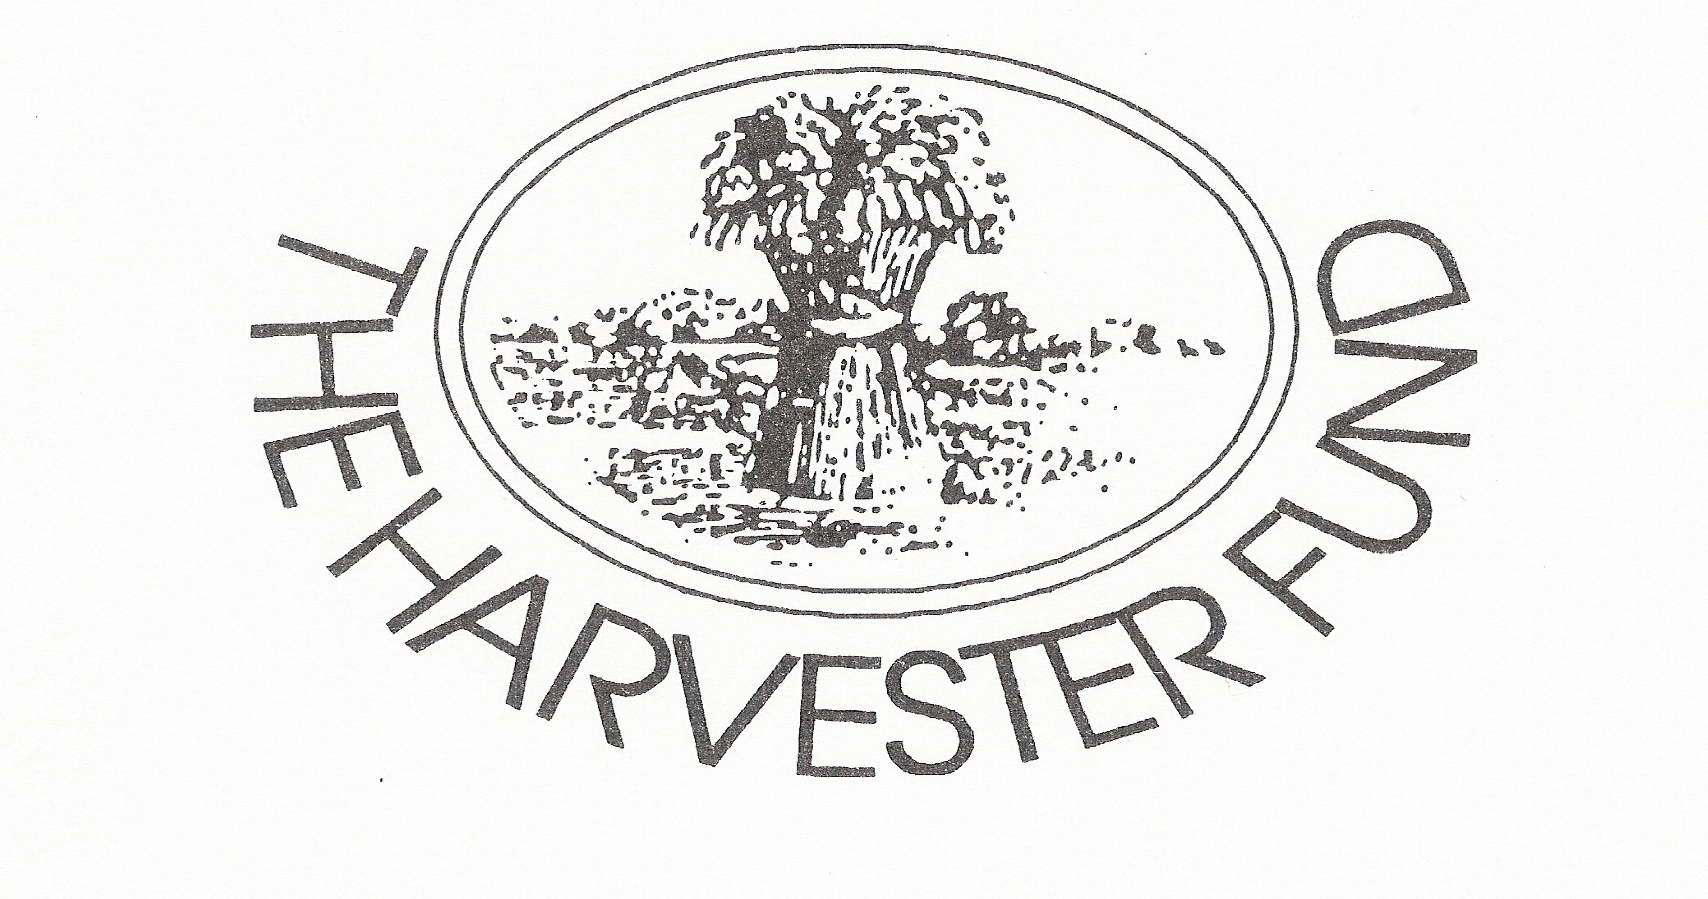
Harvester Trust Fund Application Form
Charity Registration
No. 520921
The Hayloft
Hazlett House Farm
Waterhouses
Durham
DH7 9HD
Telephone:
0191 3734575

Background to The Harvester Fund
The fund was originally set up in 1992 when several Clubs in County Durham closed due to lack of members. At the time it was agreed that the money should be held in a separate fund for the benefit of the members and not for the running of The County Federation.
Two funds were created, The Closed Club account to hold the main capital and generate interest and The Harvester Fund to receive the interest and be used to award grants and sums of money to members. Money was to be made available, by application, to members and Clubs to help them to take part in activities and training that would help them to develop and improve their skills as members and young people in their work, trade or profession. The money was to be looked after by a small group of Trustees and deposited in safe accounts which would generate additional interest which the members could benefit from.
Additional money was added to The Closed Club account when the County Proficiency Test Committee closed down. They requested that this money be used specifically towards training of members.

Name:
Address

Contact Details: Mobile: Home:
Email
Details of Application:
Outline the activity/project (include date/time/venue):

Reasons for activity/project:

Number of people and time involved:

List breakdown of costs:

Sum applied for from fund

Reason for the application:

Signed............................................................. Date:.........................................
Position in Club/County:..................................................................................
We would like to advertise successful applications to the fund.
Please tick one of the following:
Yes you may use my application in advertising ........................
No please keep my application anonymous ......................

